Welcome Checklist



Business Purpose Real Estate Loan
  - Easy Steps for New Borrowers

Introduction
Sequoia is committed to actively move your loan request through the process to a quick resolution. Sequoia and you work together to make it happen. This checklist will help you through each part of the process, so you know what to expect and what to do.

Submit Your Scenario
- Give us the details of what you want to accomplish
- Let us find the right deal for you
- We’ll send you a soft quote & a list of requirements
- Use the secure Titan portal to upload your documents


Collect Basic Documents
- Complete our application – no need for income or asset information
- Business Entity Documents
  - Certificate of Formation
  - Operating Agreement with percentage of Ownership for all parties and Signed
  - EIN number letter
- Permission for credit checks (Borrower’s Authorization)
- Picture identification on all borrowers/guarantors
  - Driver’s License
  - Foreign National? Passport & Visa
- Make sure ALL documents are legible and complete – do not cross out information


2. Property Details
- Purchase agreement (if buying)
- Current leases (if renting out the property)
- Appraisal (property value estimation) will be ordered by the Lender
- Prepare for property inspection
  - Inform any tenants
  - Appraisal company will reach out to designated contact
  - Inspection must be prepaid – you will receive a link to pay
  - Reports generally take 7-10 days

- Insurance information
  - Give us the Name, phone number & email address of your agent
  - Don’t have coverage yet? Start shopping right away!
  - Coverage of 6 months rent loss
  - Property coverage either loan amount or guaranteed replacement cost

- Title and settlement
  - You choose who you want to use
    - Purchase – may be on the contract
    - Refinance – may want to use the same company used for purchase
  - Give us the Name, phone number & email address
  - We set up the order based on what the lender needs
  - Reports can take 7-10 days

4. Review by the Lender
- Answer any follow-up questions


5. Approval and Conditions
This Photo by Unknown Author is licensed under CC BY-SA-NC
- Lender outlines the final documents needed
- Sequoia is ALWAYS available for questions
  - Let’s set a time that works for your schedule
- The sooner these documents are received the sooner you close the loan!

6. Prepare for Closing
- Settlement will reach out to schedule a closing appointment
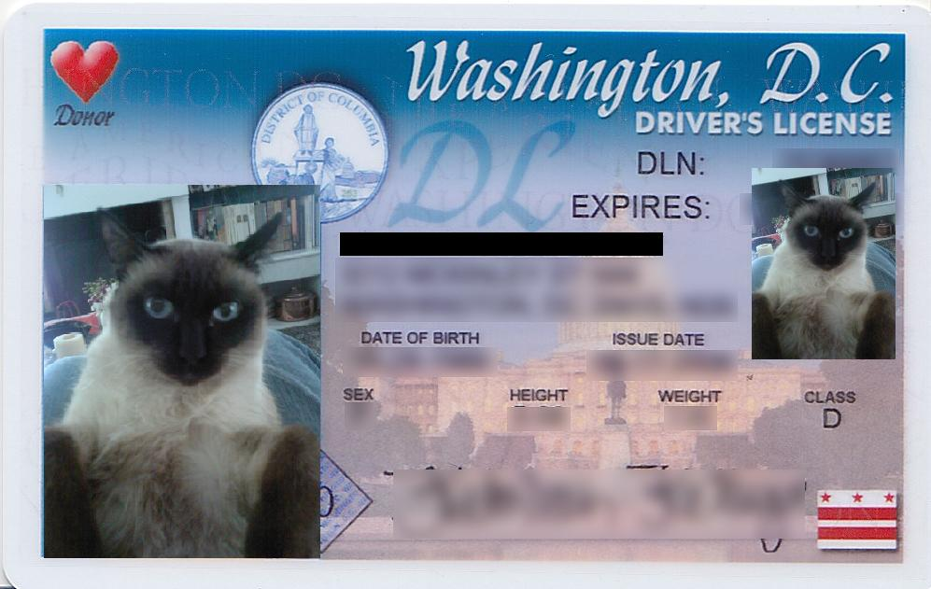
- Arrange payment of any funds needed to close your loan
This Photo by Unknown Author is licensed under CC BY-NC-ND

7. Closing Day
- Bring IDs
- Sign all documents
- Make sure wires for the loan are complete
- Collect copies of everything you sign

8. After Closing
- Lender sets up automatic loan payments
- Keep your insurance up to date
- Take care of the property

- Tell your lender about big changes

9. Support
- Contact your Sequoia Agent for help
- Ask your lawyer or accountant for advice
- Look for help from business groups if needed

10. Common Questions
- How long does it take? Depends on you! We can close in less than 21 days if you get us the information quickly.
- What are the closing costs? Appraisal, legal, insurance, lender fees, and others.
- Is a down payment needed? Yes, usually 10-30% on a purchase.
- What is used as collateral? The property, sometimes more.
- What if I’m denied? Sequoia will look for other lenders that may be a better fit.

Conclusion
It takes both Sequoia and YOU to make a loan go smoothly and quickly. Let’s team up today and get your loan moving!

